**Step 1: Drawing Basic Shapes With Python Turtle**

1. Create an new Repl by selecting the **“Python with Turtle”** language / environment.

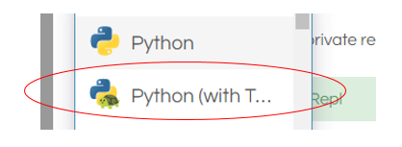

1. Begin all of your turtle programs with the following code to create a “pen”:

import turtle

myPen = turtle.Turtle()

1. Review the following chart for a list of Turtle commands.

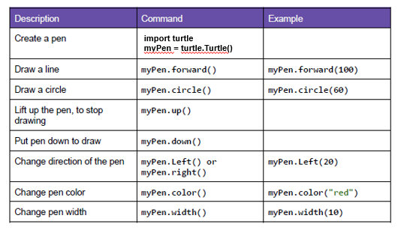

1. Use the following program to draw a red square.

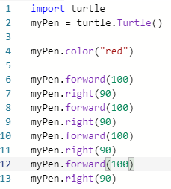

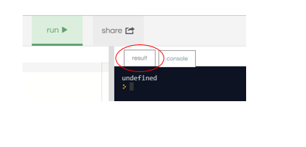

1. Switch to the “Result” window to see the square.
2. Create a program to draw any one of the shapes “b”, ”d”, or “e” shown in the figures below.   
   Provide a listing of your program code.

d)

import turtle

myPen = turtle.Turtle()

def letterX(myPen,length):

myPen.down()

myPen.right(45)

myPen.forward(length/2)

myPen.right(180)

myPen.forward(length)

myPen.right(180)

myPen.forward(length/2)

myPen.left(90)

myPen.forward(length/2)

myPen.right(180)

myPen.forward(length)

myPen.right(180)

myPen.forward(length/2)

myPen.right(45)

myPen.up()

letterX(myPen,100)

1. Create a program to draw any one of the shapes “c”, or “f” shown in the figures below.   
   Provide a listing of your program code.

c)

import turtle

myPen = turtle.Turtle()

myPen.color("sky blue")

myPen.forward(100)

myPen.right(90)

myPen.forward(100)

myPen.right(90)

myPen.forward(100)

myPen.right(90)

myPen.forward(100)

myPen.right(90)

myPen.up()

myPen.forward(50)

myPen.down()

myPen.color("red")

myPen.right(180)

myPen.circle(50)

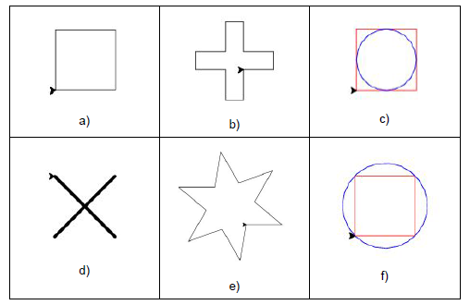

**Step 2: Christmas / Winter Theme Card**

1. Use your creativity to create a card design using Turtle.
   1. The design must have multiple figures.
   2. The design must have at least two different patterns.
   3. You may repeat patterns.
   4. Provide a listing of your program code.
   5. Provide an image of your program result.

from turtle import *

from random import randint

def create_rectangle(turtle, color, x, y, width, height):

turtle.penup()

turtle.color(color)

turtle.fillcolor(color)

turtle.goto(x, y)

turtle.pendown()

turtle.begin_fill()

turtle.forward(width)

turtle.left(90)

turtle.forward(height)

turtle.left(90)

turtle.forward(width)

turtle.left(90)

turtle.forward(height)

turtle.left(90)

turtle.end_fill()

turtle.setheading(0)

def create_circle(turtle, x, y, radius, color):

oogway.penup()

oogway.color(color)

oogway.fillcolor(color)

oogway.goto(x, y)

oogway.pendown()

oogway.begin_fill()

oogway.circle(radius)

oogway.end_fill()

BG_COLOR = "#0080ff"

oogway = Turtle()

oogway.speed(2)

screen = oogway.getscreen()

screen.bgcolor(BG_COLOR)

screen.setup(width=1.0, height=1.0)

y = -100

create_rectangle(oogway, "red", -15, y-60, 30, 60)

width = 240

oogway.speed(10)

while width > 10:

width = width - 10

height = 10

x = 0 - width/2

create_rectangle(oogway, "green", x, y, width, height)

y = y + height

oogway.speed(1)

oogway.penup()

oogway.color('yellow')

oogway.goto(-20, y+10)

oogway.begin_fill()

oogway.pendown()

for i in range(5):

oogway.forward(40)

oogway.right(144)

oogway.end_fill()

tree_height = y + 40

